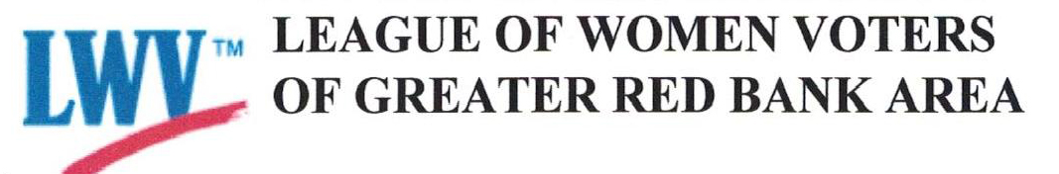

FOR IMMEDIATE RELEASE
September 15, 2021

Contact: Marianne Kligman, Voter Services Director, mariannekligman@gmail.com, 732-758-9089; 732-586-1232 (cell)
LWV Hosts the Little Silver RBR Board of Education Candidates’ Virtual Forum Candidates Forum

The League of Women Voters of Greater Red Bank will host a Virtual Candidates Forum the Little Silver RBR Board of Education Candidates’ at 7 pm on Thursday, October 6 at 7 pm. The program will be run on a Zoom Webinar platform; the public may Register here. Or go to https://bit.ly/forumRBR.

The Candidates include Eugene J. Koster, Jr., and Tara Gibb

Questions are submitted in advance of the forum and can be submitted upon registration; or email them to lwvforum2021@gmail.com using “Little Silver Representative on the RBR Board of Ed” in the subject line.

The forum will be run by the Greater Red Bank chapter of the nonpartisan League of Women Voters, an organization with an established record for fair and informative forums. A trained League moderator from outside the voting area will preside.

The League of Women Voters was established 101 years ago by helping to pass the 19th amendment. It is a non-partisan, activist, grassroots organization that believes voters should play a critical role in democracy.

###

