[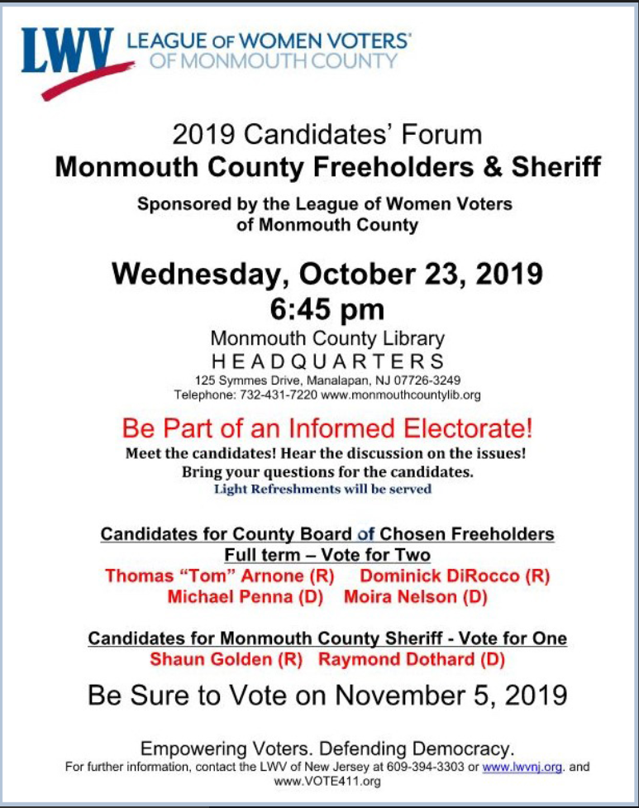](https://www.mydisneygroup.com/nationalliteracy2019)